**Wayne State University College of Education**

**Lesson Planning Framework for Effective Instructional Design**

**Teaching Intern(s):** Subica Hussain and Abigail Williamson

**School in which the lesson is being taught:** University Prep Academy - Mark Murray

**Grade level of students for whom the lesson was developed:** 2nd Grade

**Subject/content area(s) for the lesson:** Math

**Title of the lesson:** Module 4: Lesson 1 → Relate 1 more, 1 less, 10 more, and 10 less to addition and subtraction of 1 and 10.

**Time needed for lesson:** 1 hour

**Co-teaching Models:** (Appendix 6)

**1. LEARNERS & LEARNING ENVIRONMENT**

a) Engaging and Supporting Diverse Learners: Principles of Universal Design for Learning

* Overall Classroom Make-up: There are 20 students in the classroom. They are all African American and are living in Detroit or the surrounding area. The class is made up of 10 boys and 10 girls.
* Among twenty students, few of them are shy and refrain from directly answering to the posed questions. Using the Think-Pair-Strategy during the whole class instruction would increase their involvement in the discussion. Later, this might help them to become more confident to share their ideas or thoughts with the entire group. The Think-Pair-Strategy also establishes socialization, communication, and academic skills simultaneously while recognizing the importance of being part of the class community.
* This lesson incorporates many different learning styles:
  + Tactile learners will benefit from using place value disks that they can move around themselves.
  + Visual learners will benefit from the different type of SMARTBoard lessons as well as working out and drawing problems on their personal whiteboard.
  + Many of our students focus better and comprehend concepts more in smaller groups rather than in a whole group setting. They will receive more one-on-one instruction in a small group setting. To fully utilize the instructional time the lesson involves whole group instructions and then dividing the students into small groups. The teacher provides the clear purpose of the lesson during whole class instruction. The teacher meets the students with identified needs in small group (guided practice time for each group). The strategy involves gradual release of responsibility “I do, we do, you do.” The students would benefit from guided practice as“Guided instruction provides teachers an opportunity to address needs identified on formative assessments and directly instruct students in specific literacy components, skills, or strategies (Effective Use of the Gradual Release of Responsibility Model).”
* In order to meet the needs of the different learning styles in the classroom, when students are in small groups, they will have the choice of either using their whiteboard to draw out the problems that they are given or they may choose to use the place value disks and self-drawn place value template to support their learning.
* The lesson involves the use of manipulatives. In order to optimize instructional time, the small group will sit in a semi-circle on the carpet. The seating arrangement will let the teacher keep a close eye on students’ work.
* The lesson uses some new vocabulary words that might be unfamiliar to some students. For students to learn the math concept and use the learned strategy later, the teacher will teach the new vocabulary words (through various representations) during the lesson. The different descriptions of vocabulary words during the lesson will ensure that the information presented to all learners is evident and comprehensible during the lesson.
* Students will be working in small groups for the middle portion of the lesson. Each group is made up of 6-7 students with varying needs and abilities.
  + Group 1:
    - Two students in this group have trouble staying focused. In order to make sure that they are getting everything that they can during small group instruction, they will be paired with students who will be able to keep them focused and can assist them with any questions that they may have. The teacher will also be checking in on those students to make sure that they are doing what they are supposed to be doing by either giving them quick reminders when they are not focused or by giving them a small star on the top of their whiteboards.
    - Student J is struggling to learn the math concepts needed for this lesson and also has trouble staying focused when there are manipulatives or supplies involved. Since there is an odd number of students in this groups, she will be paired with the teacher when they are doing partner work in small groups. This way, the teacher will be able to monitor her as well as address any concerns or problems that she may have when it comes to the concept of the lesson.
    - There are about 4 high achieving students in this group. They will be paired with a student that may struggle with the concepts of the lesson and will also keep their partner engaged and focused.
    - Student M has Cerebral Palsy. In order to accommodate her needs, she will be allowed to lay down during the small group lesson/activity or sit in a chair if she needs too.
  + Mrs. Hodges Group:
    - This group is made up of primarily middle to low achieving students with 1-2 high achieving students.
    - Student M misses school quite regularly so she has missed the foundations leading up to this lesson. She may need some re-teaching or a quick review of some concepts.
    - Student N has some behavior issues and has trouble focusing when manipulatives are involved, especially whiteboards and markers. In order to keep her engaged, she may be placed next to the teacher and can use the place value disks instead of the whiteboards to eliminate some of the problems.
    - Student K is a high achieving student and likes to be the first person to either shout out an answer or raise his hand. He can be placed with a middle to low achieving student to help them understand the concept of the lesson. Also, giving students “think time” will help with him shouting out any answers.
  + Group 2:
    - This group constitutes of high level students and middle level students. There are six students in the group.
    - Student D and Student N will work with place-value disks. Place value disks are used as a “tool that does not ‘illustrate’ a concept” (Elementary and Middle School Mathematics p. 23). It supports the student to visualize a mathematical concept and let the student connect the mathematical relationship. The other two group will have a choice of either using the disks or a marker to draw.
    - Student D and Student N can maximize on learning new concepts using concrete objects. To facilitate Student D and Student N’s learning style, the teacher will utilize the small group instructional time to explore the new concept of relating 1 more/less or 10 more/less through the use of un-proportional tens and ones disks.
* This lesson also has some students using the computers to practice the concepts that they are learning, using an interactive website “Study Island.” The website will support students learn and practice the mathematical concepts that they learned in a way that is both educational and fun.

b) Materials & Digital Tools Needed:

* EngageNY Lesson Plan: Grade 2 Mathematics Module 4, Topic A, Lesson 1
  + Lesson Plan (one copy for each teacher)
  + Problem Set/ Exit Ticket Worksheet (1 for each student and a teacher’s copy) Appendix 1
  + RDW (Read, Draw, and Write) Anchor Chart (hanging in the classroom)
* Laminated sentence frames (one copy of each set)

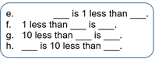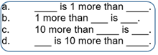

* SMARTBoard
* Teacher’s Laptop
* 4 Personal Computers (Available in classroom)
* Whiteboard, dry erase marker, dry erase and pencil (one for each student and one for the teacher)
* Place value disks (math resource room): 9 tens disks and 9 ones disks in Ziploc (one bag for group and one for the teacher)
* Timer
* PowerPoint (Appendix 2)
* Rubric (Appendix 3)
* Class Grouping and Rotation (Appendix 4)
* Classroom Seating Chart (Appendix 5)
* Adapted Co-teaching Model Chart (Appendix 6)

**2. OUTCOMES & ASSESSMENT**

a) State Standards and Student Outcomes—Learning Goals

* Standards:
  + 2.OA.1 - Use addition and subtraction within 100 to solve one- and two-step word problems involving situations of adding to, taking from, putting together, taking apart, and comparing, with unknowns in all positions, e.g., by using drawings and equations with a symbol for the unknown number to represent the problem.
  + 2.NBT.5 - Fluently add and subtract within 100 using strategies based on place value, properties of operations, and/or the relationship between addition and subtraction.
* Outcomes:

**Students will be able to:**

1. Identify and solve number patterns within one hundred while applying addition and subtraction rules.
   1. Rules: +1, -1, +10, -10
2. Use arrow notation to mentally solve addition and subtraction problems within 100.

b) Assessment and Evaluation—Evidence of Student Learning

·

* **Assessment**
* Listen to student’s response after reading a story problem. Assess student’s understanding through RDW (Read, Draw and Write) approach.
* Watch students in the way they are grouping the tens and ones on an unlabeled tens template.
* Check whether the student trades 10 ones disks with 1 tens disk and moves it to the tens column on the unlabeled template.
* Ask students to explain the specific strategies they used to solve problems.
* Students will also be informally assessed while they are on the computer to make sure that they are staying on task and understanding the new concepts.
* Tell students to do their personal best while solving problem set. Assist students who need extra support as identified in UDL.
* **Evaluation**
* Listen actively to students’ verbal answers during the whole group lesson to gather information and use it to adjust the direction of the lesson.
* Notice students’ mathematical thinking during both the whole group lesson and small group lessons.
* Evaluate the Problem Set during the debrief and address any misconceptions as they arise.
* Evaluate the Exit Ticket based on the rubric (Appendix 3) provided.

**3. INSTRUCTIONAL PRACTICE**

a) Introduction—Engaging Students, Activating Prior Knowledge, Setting Lesson Goals **(5 minutes)**

**Note: Mrs. Hussain and Miss. Williamson will team teach during the introduction.**

* + Introduce the lesson by activating the prior knowledge of place value. Tell students that today we will use manipulatives and apply mathematical strategies to solve math problems. Display the learning target slide (Appendix 4).
  + **Learning Target**: “I CAN relate 1 more, 1 less, 10 more, and 10 less to addition and subtraction of 1 and 10.”
  + Annotate the learning target with the help of the students. Let students point out words in the learning target that stand out to them. Together with the teacher, the students will comprehend and verbally tell what it means to them.
  + Display the vocabulary word slide (Appendix 4). Ask students to read the vocabulary words related to the lesson.
    - relate
    - addition
    - subtraction
    - more
    - less
    - increase
    - decrease
    - rule
    - value
    - place value

b) Instructional Procedures—Engaging Students in Actively Constructing Deep Understanding

* **Introduction** (refer to introduction section)
* **Application Problem (7 minutes)**
  + ***Note: Mrs. Hussain will lead the Application Problem, Oral Fluency, and Introduction of Station 1. Miss. Williamson will support during this time.***
  + Display the Application Problem slide (Appendix 2).

“In the morning, Jacob found 23 seashells on the beach. In the afternoon, he found 10 more. In the evening, he found 1 more. How many seashells did Jacob find in all? If he gives 10 to his brother, how many seashells will Jacob have left?”

* + Ask students to whisper read the problem to themselves.
  + Read the problem chorally as a whole class.
  + Ask: “What strategy do we use to solve story problem?”
  + Listen for the answer RDW (Read, Draw and Write).
  + Point out to the RDW Anchor Chart hanging on the wall.
  + Review the RDW procedure for problem solving.
  + Directions: Read the problem, draw and label, write an equation, and write a word sentence. The more students participate in reasoning through problems with a systematic approach, the more they internalize those behaviors and thought processes. (Excerpted from “How to Implement *A Story of Units*.”)
  + Ask students to identify the key vocabulary words that tell you which operation they should apply to find out the answer to the problem.
  + Underline the key vocabulary words and information about numbers and unit.
  + Lead students as necessary through the sequence of verbal questions they need to internalize: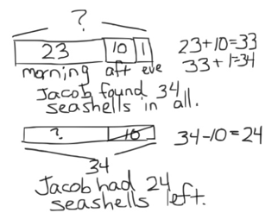
  + What do you see?
  + Can we draw something?
  + What can we draw?
  + Invite two or three students to draw on Smart Board (as time allows).
  + What conclusions can you make from your drawing?
  + Invite another student and ask, “Would you approach the problem in a different way than what your peer has suggested?”
  + Explain your thinking or strategy that you used to solve the problem.
  + Accept related mathematical diagrams or number sentence.
  + Point and bring student’s attention to the missing part.
  + Explicitly tell them our learning target is to relate 1 more, 10 more, 1 less and 10 less to addition and subtraction of 1 and 10.
  + Let the students point to the missing part in the drawings and really make that connection between the number sentence and the missing part.
* **Oral Fluency Activity: (2 minutes)**
  + Have students skip-count by tens and ones to one hundred and back down to zero while doing a physical activity (e.g., clapping hands for counting forward and slapping on knees for skip-counting backward).
* **Introduction of Station 1: (6 minutes)**
  + Display Sentence Frame slide (Appendix 2).
  + Tell students to start at 43.
  + Ask students to skip-count by 1 more.
  + Write the numbers on SmartBoard: 43, 44, 45, 46, 47
  + Tell them to skip-count by 10 more, starting 43.
  + Write the numbers on the SmartBoard: 43, 53, 63, 73, 83
  + Bring attention to the place at which number is changing.
  + Talk with your partner. Use place value language to explain what you understand about 1 more and 10 more. (Allow about 45 seconds for discussion.)
  + Listen to students’ notices.
  + Point out and explicitly say that when we skip-count by 10s or we add 10 more the number at tens place increases. While the numbers at ones place remain unchanged.
  + Point out to numbers: 43, 44, 45, 46, 47.
  + Tell students that when we skip-count by 1s, the number at the ones place increases and the numbers at tens place remain unchanged.
  + Explain that we have to subtract and add the same units, so the ones place changes when we add or subtract 1. The same happens for the tens place.
  + Complete few sentence frames together with students.
  + Cold call on some students to complete sentence frames.
  + Touch base on the learning target one more time.
  + Say that we are making a connection or relating 1 more/less and 10 more/less with addition and subtraction of 1 and 10.
  + Transition to Miss. Williamson.
* **Introduction of Station 2: (5 minutes)**:
  + ***Note: Miss. Williamson will lead Introduction to Station 2. Mrs. Hussain will support.***
  + Mention to students that the rules they are going to learn go along with the sentence frame. They are just an easier way to write them, but they are the same thing! The rules are +1 (one more/adding 1), -1 (one less/subtracting 1), +10 (10 more/adding 10), -10 (10 less/subtracting 10)
  + When students see the rule above an arrow that is next to a number, that is what they are going to be doing. For example, if students see the number 36 with an arrow next to it that has a +10 on top of it, it means that they are looking for the number that is 10 more than 36, so 46.
    - Do one of each as an example to get students familiar with the concept.
  + Let the students know that they will also be looking at patterns and trying to figure out not only what the missing numbers are, but what the rules are too.
  + Verbally say a number pattern and have students figure out the rule is.
    - Example Problem: “25,26,27,28,29” would have the rule +1
  + Next, write down a number pattern and give students some think time before calling one student up to the SMART Board to finish the pattern and write down the rule.
    - Example Problem: “75,65, 55, 45, ___, ___”
    - Look for the rule being -10 and the missing numbers: 35 and 25
  + Transition to Mrs. Hussain who will be explaining how the rotations will work and will be breaking them up into their small groups.
* **Explanation of Rotations and Transition into Small Groups: (3 minutes)**
  + ***Note: Mrs. Hussain will transit students to their stations and Miss. Williamson will support.***
  + Display Group slide. (Appendix 2)
  + Tell students that they will be divided into three groups. There will be a set of two rotations of 8 minutes each like they have in centers each morning.
  + Give instructions that when the timer goes off, Group 1 will meet Mrs. Hussain at Station 1 in front of the class door. Group 2 will meet Miss. Williamson at Station 2 in front of the Smart Board. Group 3 will meet Mrs. Hodges and sit in front of calendar wall.
  + Mrs. Hodges will direct the group at the computer station.
  + Tell students that only Groups 1 and 2 are rotating. Mrs. Hodges’ group is staying where they are. They should listen to the instructions that the teacher gives them and try their best to not touch supplies unless asked to do so.
  + Call out the names of group members and the station number.
  + The timer will go off to have students move to their first center and then again to have them begin at the center.

b) Instructional Procedures—Engaging Students in Actively Constructing Deep Understanding

* **Activity at Mrs. Hussain’s Station 1: (9 minutes)**
  + Purpose: To enable students to use a concrete representation of 10 more/less than and 1 more/less than resulting in a smooth transition to an abstract representation of the mathematical concept.
    - Post *more* sentence frames on one side of the board and *less* frames on the other side.
    - Introduce the number disks (non-proportional units) used to further develop place value understanding. Like money, the value of the disk is determined by the value printed on it, not by its size (*How to implement Story of Units*).
    - Write on one of the sentence frames, “10 less than 53 is ___.”
    - Model addition and subtraction using number disks and unlabeled tens template drawn on the whiteboard.
    - Ask, “What is 10 less than 53?”
    - Teacher says, “I will place 3 ones disks and 5 tens disks. I am now looking at the number 53. I will make 10 less (physically removing a 1 tens disk). What is 10 less than 53?”
    - Write the answer on the template and then state a full response: “10 less than 53 is 43.”
    - Compare the written response with the disks.
    - Pass out the whiteboards and markers.
    - Instruct on how to handle and take care of manipulatives. Give clear instructions to students on what are the expectations.
    - Have students do two or more examples using disks before transition to abstract.
    - Pass out the problem set.
    - Have students do their personal best to complete problem set.
    - Utilize the time to observe any misconception.
    - Address misconception at that moment.
    - Have students do the exit ticket.
    - Let students work independently on the exit ticket.
* **Transition to Rotation 2: (1 minute) *Miss. Williamson***
  + The timer will go off signaling that it is time to transition. The students should assist their teacher in making sure that their center is clean before standing up and waiting for further instructions.
  + Students will take their personal whiteboard and their problem set with them to their next center.
  + Ask students to transition quietly to next station and wait for the next timer to go off that will let them know when to begin.
* **Activity at Miss. Williamson’s Station 2:** **(9 minutes)**
  + Each student will receive a whiteboard to use for the mini lesson, but the teacher will keep the markers and erasers until they need them. This will help students be less distracted by the supplies.
  + Review the more/less rules with students on the whiteboard and how to write them:
    - These are the four rules that students should know by the end of this lesson:
      * +1, - 1, +10, and -10. This is the same as saying add one, subtract, one, add 10 and subtract 10!
  + Practice writing a few numbers on the whiteboard using the rules and how they are written so students can get used to seeing what they look like.
  + Explain to students that 1 more is just like adding one, 1 less is the same as taking away 1, 10 more is just like adding 10, and that 10 less is the same as taking away 10.
  + Write down numbers with an arrow next to it that has one of the rules on top of it from the student’s Problem Set on the teacher white board. Call on individual students to help answer the problem. The students will then write down that answer on their Problem Set.
  + Next, have students listen as you say a few number patterns to them. Have them raise their hands when they have figured out the more or less rule. Once they understand that concept, do the problems from the Problem Set with them.
    - Example patterns:
      * “45,46,47,48,49” (1 more)
      * “23,33,43,53,63” (10 more)
      * “76,75,74,73,72” (1 less)
      * “65,55,45,35,25” (10 less)
    - Depending on whether students need it, more examples can be done!
  + Write a series of numbers on the whiteboard. Students can copy the numbers down on their own white board and fill in the blanks and the rule on their own (show what you know activity). Once they show you their pattern, check to make sure that the rule as well as the numbers in the blanks are correct. If time allows, do some more examples.
    - Examples:
      * 18,17,16, ___, ___, ___.
      * Look for the answer -1 rule, and 15, 14, 13
  + Have students complete the last few problems on their Problem Set quietly. Once that is done, the teacher will check it over before having them move onto their Exit Ticket. The Exit Ticket must be done independently so that the teacher can check for individual student’s understanding.
* **Computer Center:** 
  + At this center, students will be using Study Island to complete lessons on this concept either on the classroom set of computers or on laptops.
  + The teacher (Mrs. Hodges) at this center may pull out students to do individualized lessons with them, depending on their needs.
  + Students may also work on place value games when they finish the Study Island lesson associated with this lesson.

c) Technology as a Tool for Effective Teaching & Learning

* The SMART board supports differentiated learning styles. It engages visual learners as well as audio learners. The interactive element lets tactile learners have hands-on experiences. Students are more engaged which leads to a better understanding of the lesson.
* Incorporating technology in the classroom: “environment is likely to change the way teachers impart knowledge to students and at the same time simplify the learning process for students” (The Advantages of SMART boards in the classroom, 2014).
* The PowerPoint presentation saves time during the lesson. Instead of the teacher writing on the whiteboard, the information is typed ahead of time.
* The use of SMART Ink lets the teacher interact through highlighting the text and the ability to save for later use.
* Study Island is a learning based website that is tailored to individual students’ strengths and where they need help on. Websites are, “an online tool that provides standards-based instruction, practice and testing for the End of Grade (EOG) assessments” (Kenny 71).

d) Closure—Students Summarizing and Synthesizing Their Learning

* **Transition from Small Groups to Whole Group (4 minutes) Miss. Williamson**
  + The timer will go off signaling the end of the rotations. Students should help the teacher at that center organize the materials. If students are at the computers, they should completely log off Study Island, close their internet browser and turn off their computer. Once everything is organized and closed, students should stand up quietly at their center.
  + The teacher in charge of this transition will look for quiet groups to call back to the carpet. They should bring their whiteboard and problem set with them to the carpet.
  + Before beginning the Debrief portion of the lesson, the teacher will wait until all students are settled and ready to listen before starting.
* Debrief **(7 minutes)**

**Note: Miss. Williamson will lead the Debrief and closure. Mrs. Hussain**

**will support.**

* + Complete problems from either the Problem Set or made up problems with help from students.
  + Start off with a *more* or *less* statement. Ask students what the difference is between more and less.
    - Look for more means adding, less means subtracting.
  + Write at least 2 examples of *more* or *less* statements on the board. Use the cold call sticks or call on a student to answer the question. Make sure to ask about how they came up with that answer!
    - Example questions:
      * 10 less than 66 is ____
      * 86 is ______ than 96.
  + Ask students to name the rules that they were learning about. Write them down on the SMART Board for them to reference.
    - Look for +1, -1, +10, -10
  + Using those rules, write down a few number using the arrow method on the SMART Board. Call on students to help determine what the new number is. Make sure that they explain how they came up with that new number.
    - Example questions and responses:
      * 39 → +1 ________ (you are adding one to 39 to get 40)
      * 56 → +10 ________ (you are adding 10 to 56 to get 66)
  + Next, move onto patterns. Write down a set of numbers (either made up, or from the Problem Set) and have at least 2-3 blanks with a blank space for the rule. Give students think time to think about what the missing numbers are as well as what rule is. Call a student up to the board to complete the pattern, determine the rule, and explain their reasoning.
    - Examples:
      * 45,55,65, ___, ___, ___ Rule: _________
      * 22,21,20,19, ___, ___, ____ Rule: ________
  + If time permits, do a complete the sequence problem from the Problem Set. This may be tricky for some students, so some assistance may be needed. Explain to students that they can break it up instead of trying to do the whole thing at once. Try having them cover up the end of the problem to make things easier to figure out!
    - 61 → -1 ______ → -1 ______ → +10 ______ → +10 _______ → -1 _____

**4. REFERENCES & RESOURCES**

* **Reference from website:**

How to Implement A Story of Units - Welcome to EngageNY. (n.d.). Retrieved

January 27, 2017, from

<https://www.engageny.org/sites/default/files/resource/attachments/how_t>

[o_implement_a_story_of_units.pdf](https://www.engageny.org/sites/default/files/resource/attachments/how_t)

Place Value Disks - A Valuable Tool? (n.d.). Retrieved January 28, 2017, from

<http://teachingandlearningcommunity.blogspot.com/2014/02/place-value->

[disks-valuable-resource.html](http://teachingandlearningcommunity.blogspot.com/2014/02/place-value-)

Grade 2 Mathematics Module 4, Topic A, Lesson 1. (n.d.). Retrieved February

1, 2017, from <https://www.engageny.org/resource/grade-2-mathematics-module-4-topic-a-lesson-1>

Home | National Center On Universal Design for Learning. (n.d.).

Retrieved January 26, 2017, from http://www.udlcenter.org/

Effective Use of the Gradual Release of Responsibility Model. (n.d.). Retrieved January

26, 2017, from <https://www.mheonline.com/_treasures/pdf/douglas_fisher.pdf>

Grade 2 Mathematics. (n.d.). Retrieved January 29, 2017, from

<https://www.engageny.org/resource/grade-2-mathematics-module-4>

[file:///C:/Users/subica/Downloads/math-g2-m4-mid-module-assessment.pdf](https://www.engageny.org/sites/default/files/resource/attachments/math-g2-m4-full-module.pdf)

Study Island Overview Video. (n.d.). Retrieved February 05, 2017, from

http://www.edmentum.com/resources/videos/study-island-overview-video?subject=Join Us In A Little Friendly Competition&body=We just registered for the Edmentum Academic Sprints%21 Sign up today to have a friendly competition against us for a chance to win 10 Chromebooks and Edmentum credit for your school. Here is the link to get registered and complete details of the contest%3A%0D%0Dhttp%3A%2F%2Finfo.edmentum.com%2F2016-SI-SpringContest_Form.html

* **Reference from article:**

Kenney, L. (2011). Elementary Education, There’s an App for That: Communication

Technology in the Elementary School Classroom . *The Elon Journal of*

*Undergraduate Research in Communications,2*(1), spring, 67-75. Retrieved

February 05, 2017, from

<http://www.elon.edu/docs/e-web/academics/communications/research/vol2no1/>

07kenney.pdf

* **Reference from book:**

Van de Walle. A. J, Karp. S. K. & Bay-Williams. M. J. (2004). *Elementary and middle*

*school mathematics: Teaching developmentally*. New Jersey: Pearson Education.

**5. PROFESSIONAL RESPONSIBILITY: Teacher Reflection**

The math lesson was engaging and effective. It involved the use of technology, mathematical tools, and movement within the classroom space. In order to make the lesson effective, it is important to implement methods to keep students engaged throughout the lesson. By keeping the end goal in mind, the activities were designed and aligned for students to be successful. The use of manipulatives supported the visual learners to smoothly transition from concrete to abstract mathematical concepts. Introducing the math vocabulary at the beginning of the lesson let the students comprehend the mathematical concept and explain their thinking using the specific vocabulary. During the lesson, I encouraged the students to give their answer or explain their thinking in terms of place value.

The transition from whole group to small group gave the students the opportunity to have more one-on-one interaction with the teacher. It also provided me an opportunity to address the needs of the students. I am glad that my teaching partner and I carefully grouped the students based on their strengths and weaknesses. The heterogenous grouping worked well. The students who needed extra support were more eager to work in small groups. I found that they could share their thinking process with confidence. Their participation provided me the evidence of their understanding.

At one occasion, Student J was counting by tens on fingers. I quickly responded during my small group interaction and provided her the manipulatives (number disks) to visually see the concept and then have her mentally count by tens without using the fingers. She responded correctly to the next question. I asked her, “How did you come up with the answer without counting on fingers so quickly?” She said, “I simply added 1 in the tens place.” For the students to be successful I believe small group learning is an effective method. To achieve meaningful results, it is important to learn effective classroom management techniques to implement station teaching.

During the whole group lesson, the use of various strategies, such as, Think-Pair-Strategy and cold-calling on students provided me with the opportunity to check their understanding and let me make informed changes during the lesson to accommodate the students. I also used verbal on going formative assessment strategy, probing them to explain their thinking or strategy they used to solve the problem. Another strategy suggested by the instructional coach during coaching conversation is Think-Aloud strategy. I will model and incorporate this strategy in future lessons. The Think-Aloud strategy would support students to become more adept in comprehending the math problem.

The students completed the exit ticket at the end of the lesson. The exit-ticket exhibited the evidence of their learning. The data gathered from the exit-ticket provided me insight of students’ levels of understanding. The use of the exit-ticket as formative assessment provided me the necessary information to identify strengths and weaknesses of the students that I can use to plan for next day.

I enjoyed the overall experience of teaching this lesson. It lived up to my expectations. We as a team planned it together and considered every aspect of the lesson. The lesson involved quite a lot of transitions. During the lesson, we made sure that we do not lose much time in transitions and utilize all the instructional time constructively. Keeping the timer throughout the lesson helped us to keep track of the time and do little adjustments here and there. I understand that as an educator I must be flexible and sometimes quickly respond to student’s need and take decisions that are in his/her best interest. The opportunity to co-teach the lesson let me improve my lesson planning and teaching skills.

Appendix 1

Problem Set/Exit Ticket

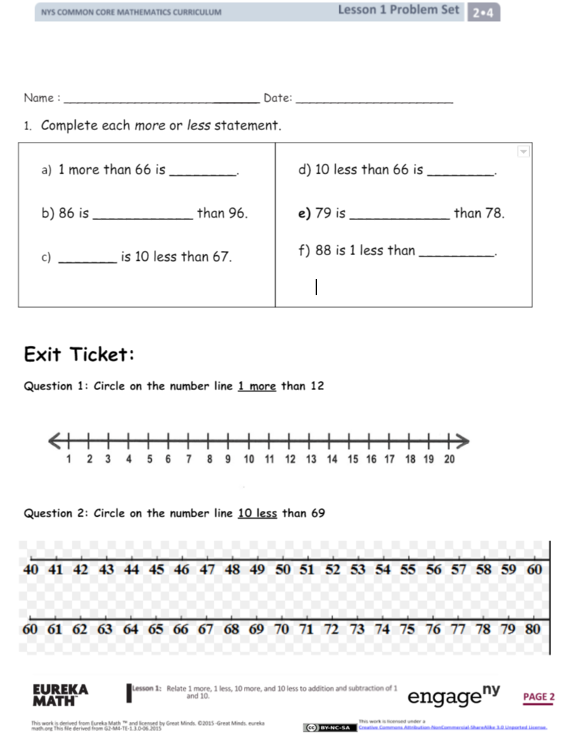

Appendix 1 (Cont.)

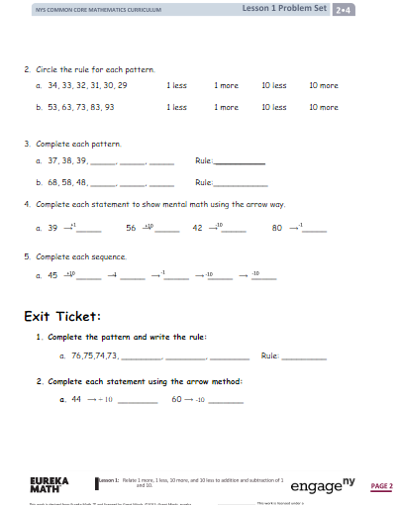

Appendix 2

PowerPoint

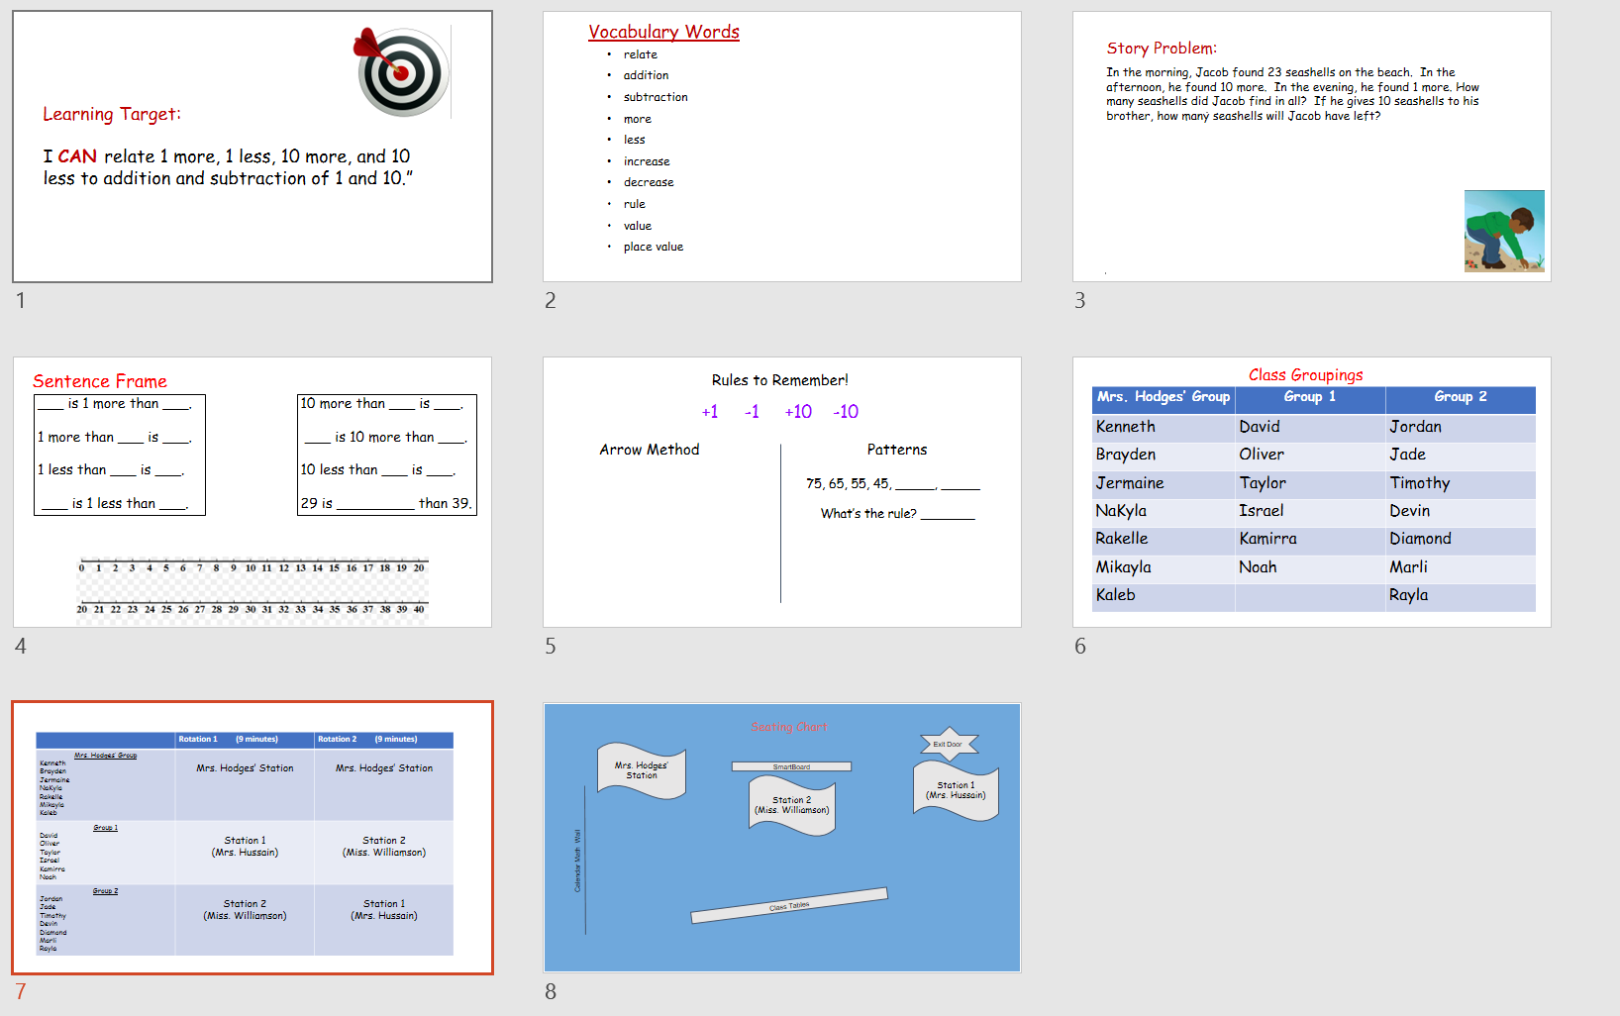

Appendix 3

Rubric 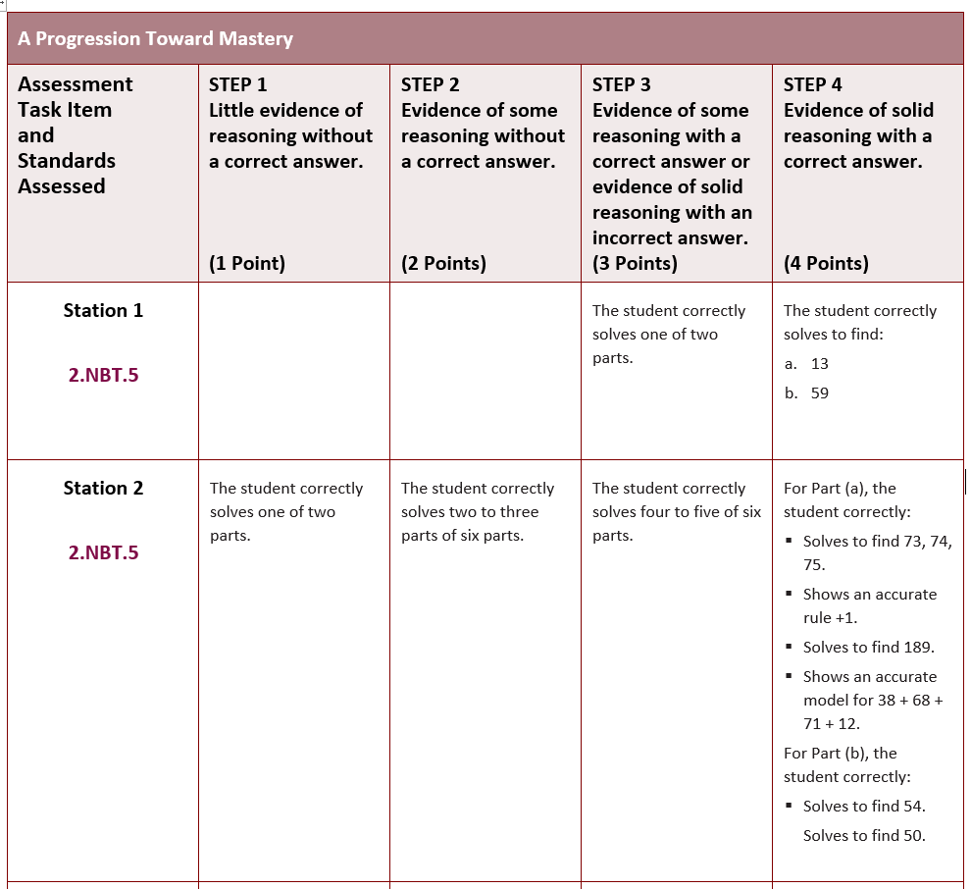

(adapted from EngageNY)

Appendix 4

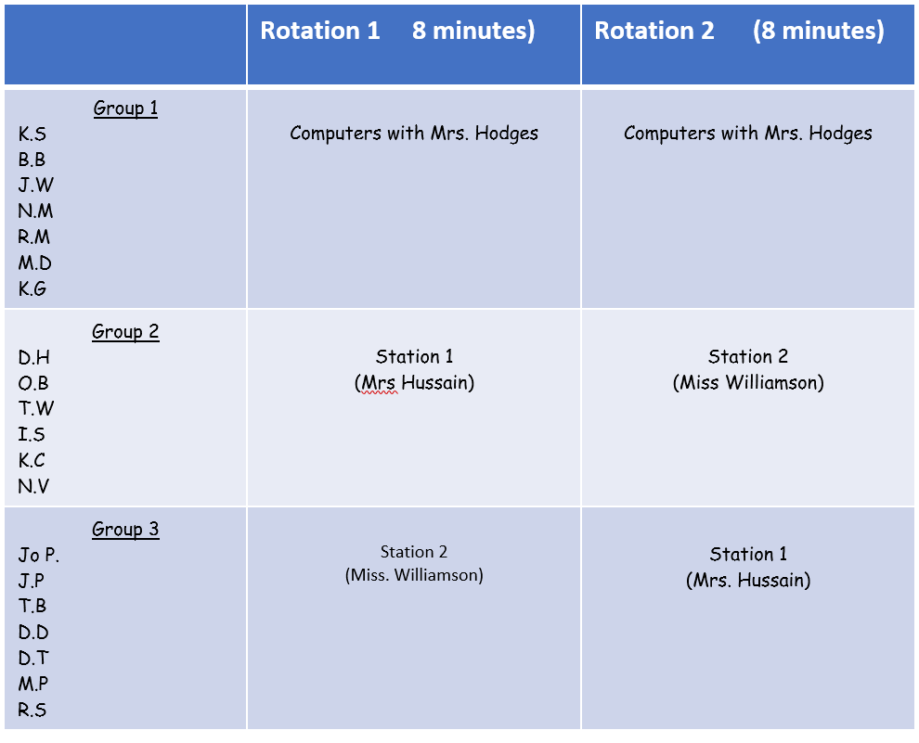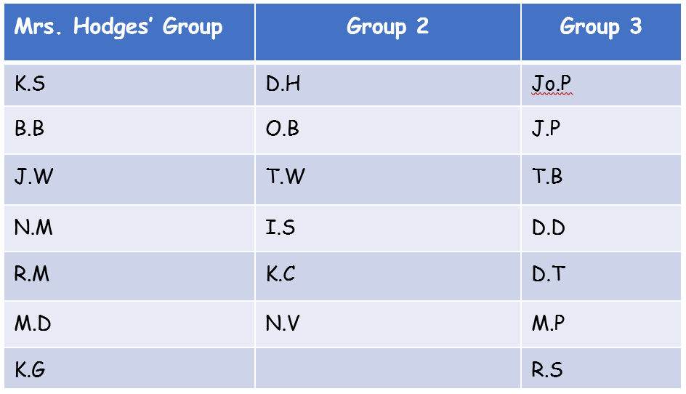 Class Groupings/Rotation Schedule

Appendix 5

Classroom Seating Chart

SMARTBoard

Miss. Williamson’s Center

Computers

Mrs. Hodges Computer Group

Mrs. Hussain’s Center

Tables

Door

Appendix 6

**Co-teaching Models used during the lesson:**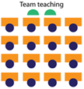

Introduction:

Mrs. Hussain and Miss. Williamson together will team teach and introduce the lesson and annotate the learning target. Mrs. Hodges will observe.

Application Problem, Fluency and Introduction of Stations: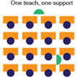

This part of the lesson utilizes One teach, one support Model. Mrs. Hussain will lead the application problem, oral fluency and introduction to Station 1. During this time, Miss. Williamson will support the students and Mrs. Hussain. Mrs. Hodges will observe.

Miss. Williamson will lead introduction to Station 2. Mrs. Hussain will support the students and Miss. Williamson.

Concrete:

The concrete part of the lesson adapts station teaching, where students will be divided into three small groups based on identified needs of each students. One of the three teachers (Miss. Williamson, Mrs. Hussain, and Mrs. Hodges) will lead each group.

Debrief and closure: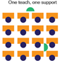

Debrief and closure will adapt One teach and one support Model. Miss. Williamson will debrief the lesson and Mrs. Hussain will support the students and Miss. Williamson. Mrs. Hodges will observe.